15.4: Denoting the speed of light by c, 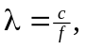and
a) 